6. Create an R list containing vectors, matrices, and functions; display contents.
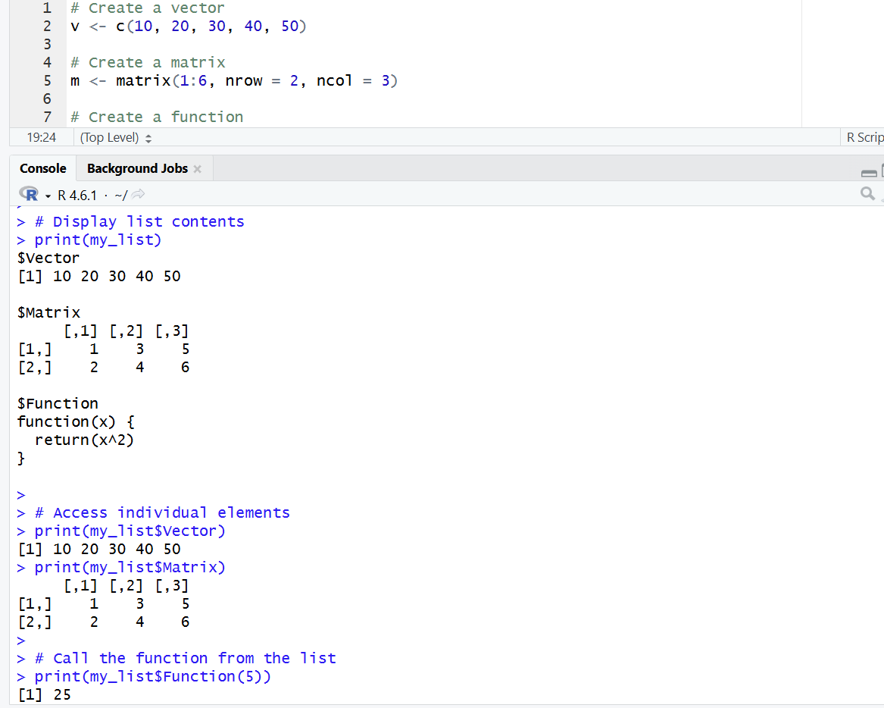
Result
An R list containing a vector, matrix, and function was successfully created and its contents were displayed.

7. Write R programs for basic tasks: Factors of a number, generate a vector of 10
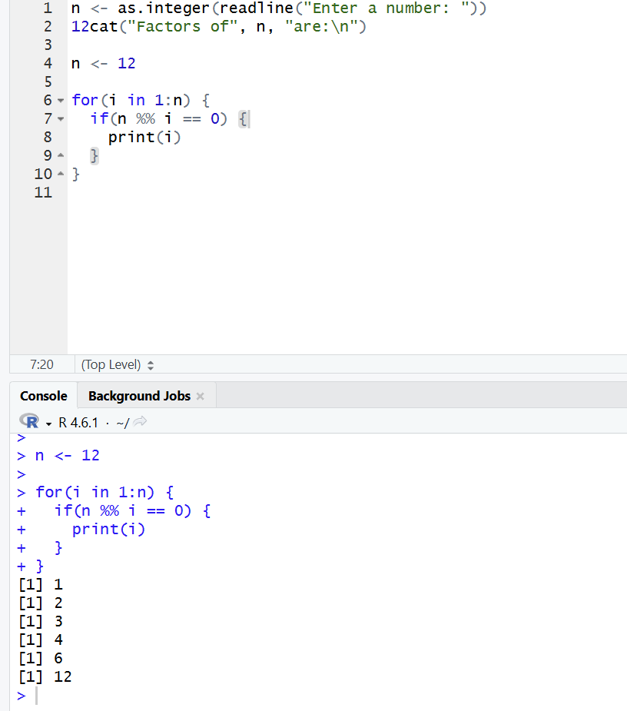
random integers between -50 and 50, print numbers 1–100 with FizzBuzz logic.

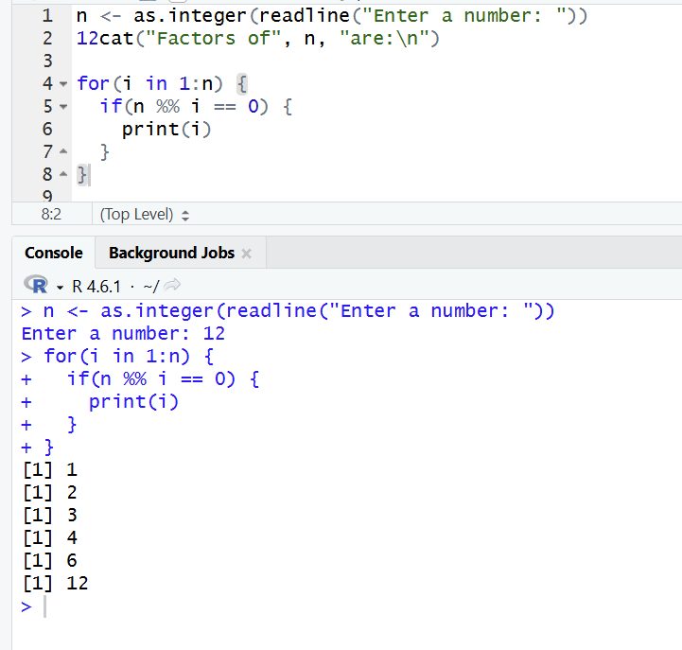
Result:
Factors, random integers, and FizzBuzz values were generated successfully.
The output was displayed correctly according to the given conditions.

8. Generate random numbers from a normal distribution; count occurrences.
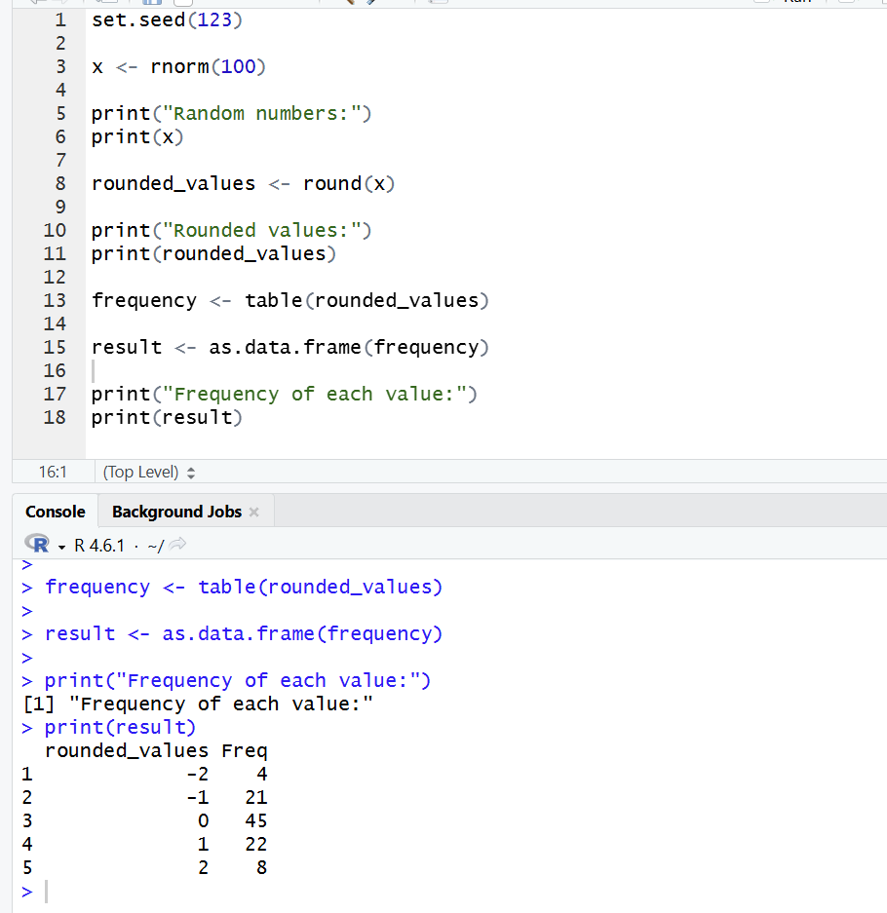

Result:
Random numbers from a normal distribution were generated successfully.
The rounded values adn their frequencies were counted and displayed correctly.

9. Create empty plots with specified axis limits.
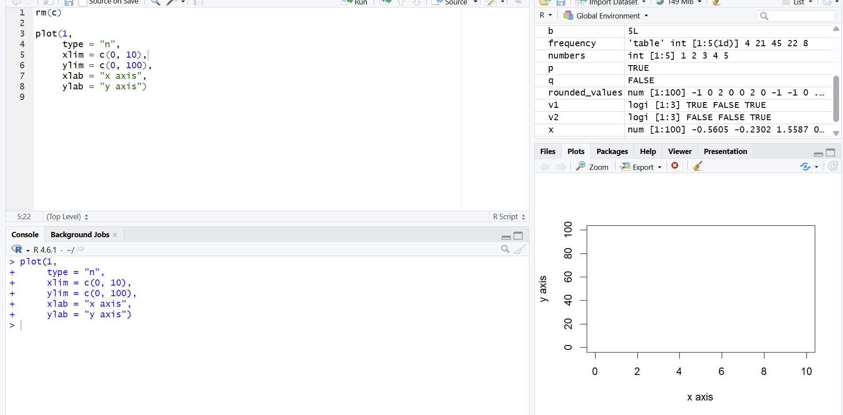

Result:
An empty plot with specified X-axis and Y-axis limits was created successfully.
The plotting area was displayed correctly with teh required axis labels.

10. Create and explore a data frame exam_data with name, score, attempts, and
qualifying fields. Perform extract, add row/column, sort, save to file.
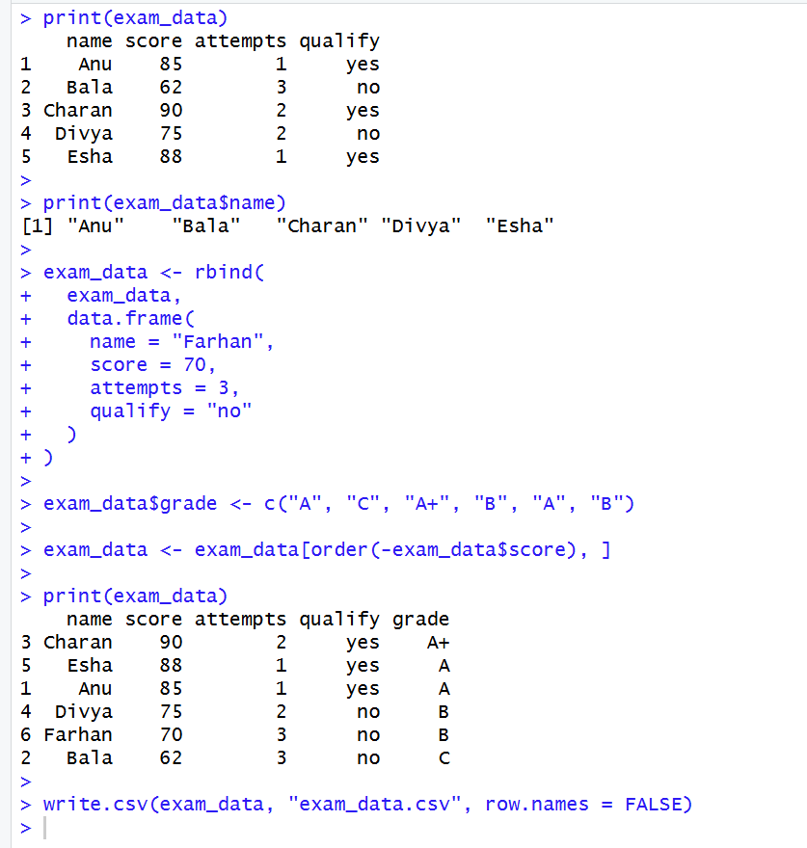

Result:
The exam_data data frame was created, modified, and sorted successfully.
The updated data was displayed adn saved successfully as a CSV file.

